**Introduction**

Technology has transformed education. Online enrollments are growing because students are seeking flexibility. According to a study at Drexel University, from 2002 to 2014, the number of students enrolled in at least one online course increased from 1.6 to 5.8 million students. Online learning provides universities opportunities to expand access to students who may not be able to attend a class on campus on a regular schedule due to a variety of different reasons including employment, children, transportation, disability, etc. Universities offering online learning can accommodate students across the world. Guidance, research, and innovative approaches to program and course formats, student engagement, and support services is essential to online learning and student success. Research shows that when students stop out, it can put them at greater risk of non-completion.

Schools have a variety of metrics to evaluate their online education programs. The metrics include engagement rates, completion of courses, scores on tests, and graduation rates. It is important for online programs to be successful because the educational system plays an important role in defining success for people. New employees find it easier to adapt to the working environment when skills are completed by a natural usage of various tech devices and online tools. Universities need to consider students’ desires as well. Students want schools to adapt to their learning needs and diverse credentials and certificates. They want personalized learning experiences. Big data and analytics can be used to study students desires and progress.

**About the Data**

Data was collected from a survey of five schools implementing the same self-paced math course, with 35 lessons. The semester is about ¾ of the way through.

There are 30 sections total.

For each section, we record the number of students who are:

• Very Ahead: more than 5 lessons ahead

• Middling: 5 lessons ahead to 0 lessons ahead

• Behind: 1 to 5 lessons behind

• More Behind: 6 to 10 lessons behind

• Very Behind: More than 10 lessons behind

• Completed: Finished with the course

The data is complete. There are no missing values. The data is in the appropriate format, except for school needs to be changed to a factor, the other columns are integers, which is correct.

**Analysis**

After aggregating the data, there are 13 sections in A, 12 in B, 3 in C, 1 in D, and 1 in E. To get an idea of how many students were surveyed, adding a total column is necessary. There is a wide range of students in each section, the best comparison is based on percentages.

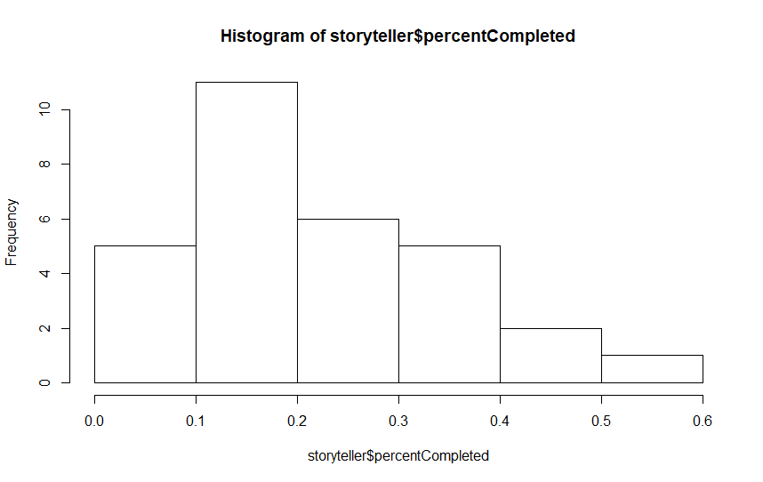

22% of students completed the course. The breakdown by school is:

A B C D E

0.1608333 0.2874303 0.2578348 0.1363636 0.2327586

**No students surveyed were very ahead.**

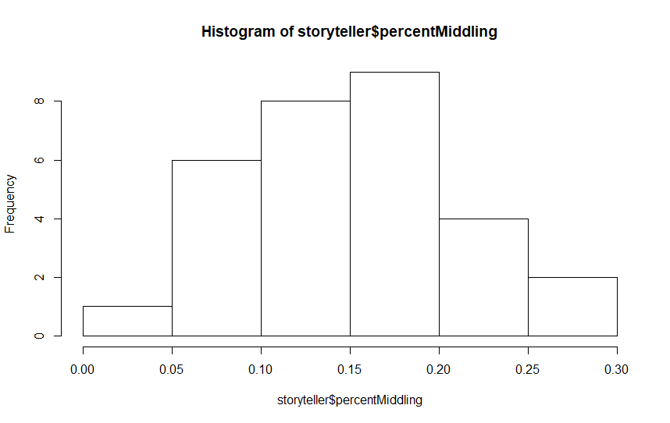

15% of students fell in the middle. The breakdown by school is:

A B C D E

0.11877345 0.19195177 0.13461538 0.13636364 0.09482759

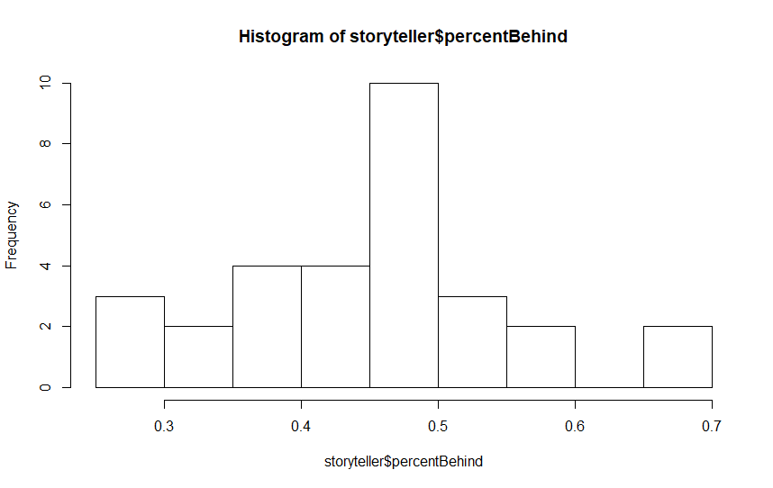

45% of students are behind. The breakdown by school is:

A B C D E

0.4811084 0.4388482 0.4266382 0.3636364 0.4827586

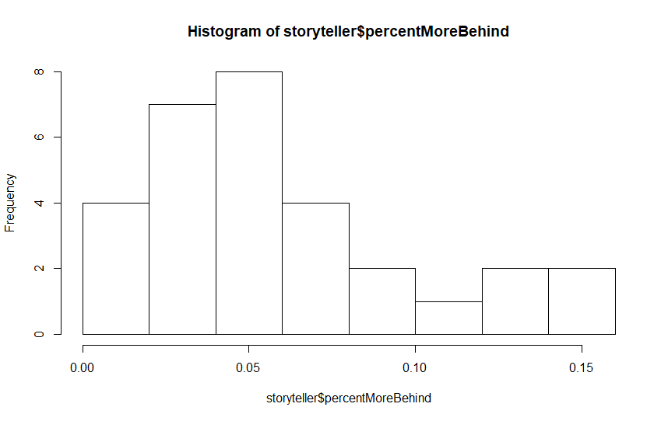

6% of students are more behind. The breakdown by school is:

A B C D E

0.07745910 0.03409491 0.05341880 0.09090909 0.06034483

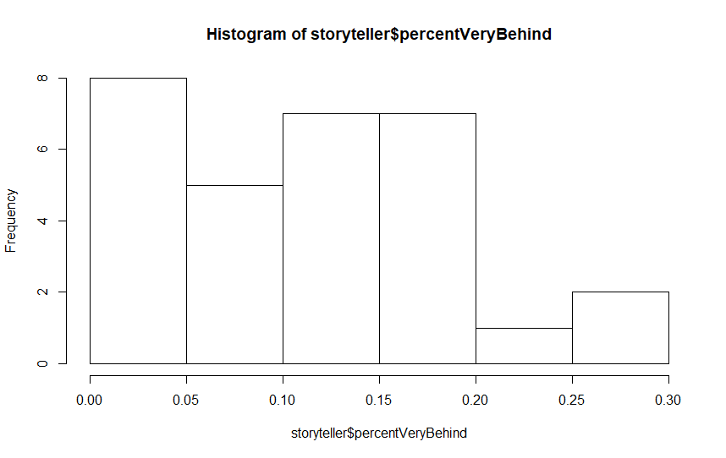

12% of students are very behind. The breakdown by school is:

A B C D E

0.16182576 0.04767473 0.12749288 0.27272727 0.12931034

**Results**

The results are based on percentages. Creating a comparison data frame made the data much easier to analyze. Considering the variation in sample size between schools, the results were more consistent than expected.

* Completed: Schools B, C, and E were above the 22% average.
* Very Ahead: No students fell in this category.
* Middling: B was above the 15% average. C and D were close to the average but fell below.
* Behind: B, C, and D were below the 45% average.
* More Behind: B was below the 6% average.
* Very Behind: B was below the 11.5% average, and D was much higher than the average.

School B students scored the best as far as keeping up with the work. D had inconsistent results which makes sense because there were only 23 students from that school. Students from A are having trouble keeping up with the work load.

**Conclusion**

The data is helpful to assess a limited number of aspects of online courses and schools. To do a proper analysis much more data is needed. There should be more consistent data, for example, similar sample sizes from the schools. Data on grades are needed to accurately evaluate the courses. The data provided shows how quickly the work is being completed, not if the students are retaining the information.

Next steps for the analysis would be to collect grade data now and at the end of the term. Then analyze how well students did that kept up with the work and those that did it at the end. A survey would add value to the data as well, for example are students not keeping up with the work because the information is too difficult, the student is too busy, or not interested.